Agile Meets Design Thinking

Peer-Reviewed Assignment

# What am I doing?

Overview

For this assignment, you’ll be developing:

1. Project description
2. Brainstormed list of personas
3. Real-life examples of your top persona
4. Problem scenarios, alternatives, and value proposition trios

# Part 1: Positioning Statement

For car dealers who own or lease dealerships, CUVIS (Certified and Used Vehicle Inventory System) is an enterprise software solution that will provide new capabilities for industry-standard dealer processes, including: digitization of the certification and delivery processes, increased reporting options, additional program admin controls, and provide role-based dashboards for inventory management. Unlike standard basic solutions in the field, our product has been carefully formulated and validated against best practices, better compliance controls and provide awesome customer experience and build loyal customer base who will return to the same dealer for vehicle accessories and service.

# Part 2: Brainstorm Personas



|  |  |  |
| --- | --- | --- |
|  |  |  |
| Jennifer the Program Admin | Craig the Auto Dealer | The product we are trying to launch is a B2B |
| Chris the Facilities Manager | Toni the Salesperson | product and since Craig the Dealer is the owner |
| Kim the Super Admin | Samantha the Customer Support Agent | of the dealership and will be our primary |
| Craig the Auto Dealer | Jennifer the Program Admin | customer who will be directly interfacing with |
| Amy the Program Lead | Kim the Super Admin | our product regarding managing his dealership |
| Toni the Salesperson | Amy the Program Lead | vehicle inventory and he will also be interfacing |
| Cody the IT Lead | Cody the IT Lead | with the end customer. |
| Jose the Front Desk Staff | Bryan the Marketing Person | The goal of my product is to onboard maximum |
| Samantha the Customer Support Agent | Chris the Facilities Manager | dealers on to our program and retain them by |
| Bryan the Marketing Person | Jose the Front Desk Staff | providing the best solution in the market. |

Part 3: Make Your Persona Testable & Actionable with a Screener

The reason for screening this persona is to know if this persona is knowledgeable or involved in the vehicle certification and sales process. And they understand the details of the process.



|  |  |  |
| --- | --- | --- |
|  |  |  |
| Craig the Auto Dealer | What percentage of your used vehicle sales are certified vehicles in the last month? | Approximately 26% |
| How long does the certification process take for each vehicle? | 10-15mins |

# Part 4: Develop Problem Scenario, Alternatives, Proposition Trios

Drafting PS/JTBD for Craig the Auto Dealer



|  |  |  |
| --- | --- | --- |
|  |  |  |
| No visibility to the used vehicles that are eligible to be certified in their current inventory management system. It is hard and time consuming to complete the pre-certification checks before certifying a vehicle. | Craig the auto dealer currently selects each used vehicle in the system and manually validating the pre-certification certification criteria check- list that includes:  Model Year >= 2016 Mileage <= 40,000 miles  Any recalls or exceptions on the vehicle? Any remaining original warranty?  What is the last service date? Valid Carfax tests?  And if the vehicle passes all the above  pre-certification checks, then that vehicle will be marked as certification eligible and will be put in the queue for the auto certification process to kick in. | Automate the vehicle certification process end to end by validating against all the pre-certification criteria checklist.  And when there is a vehicle that passes all the pre-certification criteria,  then send an alert to the dealer dashboard (which dealers check multiple times every day for any inventory alerts) with the actual number of vehicles that are ready to be certified  This will reduce a lot of manual effort from dealers. Currently they are spending 10-15mins on each vehicle pre-certification. They can use this time to engage with customers to sell more vehicles and also, they can add more certified vehicles to their inventory that is available for sale. |
| Cannot filter the vehicle inventory based on the | Currently, when Craig the auto dealer gets any | 1) Add a feature where the dealer can click |

|  |  |  |
| --- | --- | --- |
| alerts that Craig sees on the dealer dashboard. So, it's hard to check the vehicles directly in the system that needs his immediate attention. | vehicle exception alerts on his dealer dashboard, he goes to the vehicle inventory screen in the inventory management system and looks for the vehicle identification number (VIN) and then takes required action for that vehicle to clear the exception that was flagged.  Sometimes, when they have a lot of inventory in the system, it is hard to scroll through the entire list to find the VIN that he is looking for based on the alert he received on the dashboard. | on the alert on their dashboard and that takes them directly to the inventory screen.  2) Add an alert filtering feature on the dealer’s inventory screen. So, that dealer can consciously select and filter the specific alerts that need their immediate attention in their inventory screen. |

# Part 5: Design a Solution for Your PS/JTBD with User Stories



Epic 1: As Craig the Auto Dealer, I want to have visibility for the list of vehicles that are ‘ready to be certified’ in the system. So, I can decide on my next steps.

Epic 2: As Craig the Auto Dealer, I want to have an alert filtering feature on my dealership inventory screen. So, I can consciously select and filter the alerts that need my immediate attention and be able to display those specific alerts only on my inventory screen.



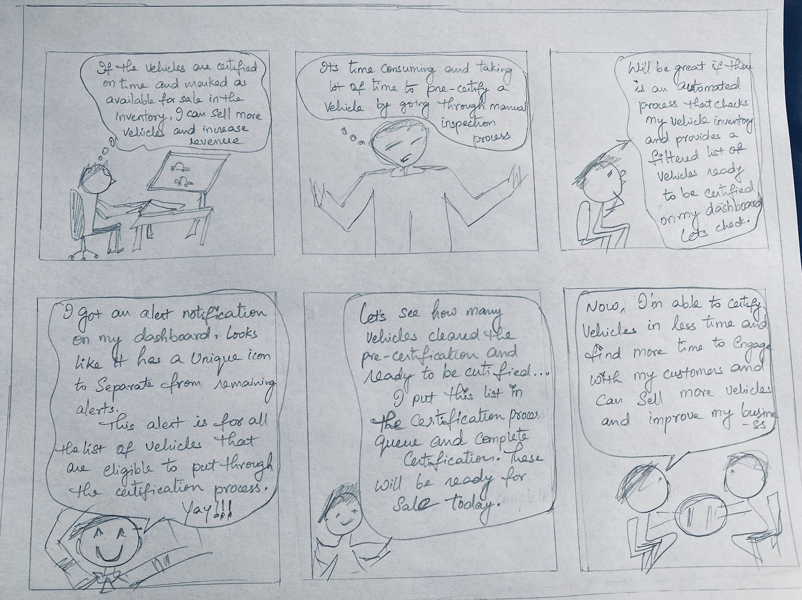





|  |  |
| --- | --- |
|  |  |
| As Craig the auto dealer, I want to see the ‘ready to be certified’ alert on my Alerts Dashboard. So, I receive an alert on the vehicles that qualify to be certified and need my attention to inspect, certify and sell the vehicle. | * The current alternative is inspecting manually. This automation of grouping all the vehicles that qualify to be certified will make dealer work easy and in less time. * This feature will check and update the inventory list real time. So, the status of each vehicle in the inventory will be current. * Conversion rate of vehicle in the inventory to certified to sold status increases by at least 10-12% * Due to freed up time for dealers from manual vehicle certification process, the customer engagement time and focus on sales increases by 8-10% |
| As Craig the auto dealer, I want the ‘ready to be certified’ alert on my Alerts Dashboard to be displayed along with a unique icon based on the vehicle status in the inventory. So, I will have a clear snapshot of the alerts and can easily identify each flavor of the alerts. | * Adding iconography to the feature will help the dealer with easy identification and immediate attention to the alert. * This can help scale up the alerts dashboards, as new requirements surface for additional alerts for dealers. |